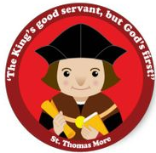
EYFS Home Learning
Dear Parents/Carers,
With all the concerns over the coronavirus outbreak and how this might impact schools and your child’s learning, we wanted to offer you some ideas to help you continue their education during any potential school closures. We have some ideas and links for further ideas and information within this letter.
Nursery:
Please enjoy a variety of different experiences within the home environment that all aid in your child’s development. For example, baking, cooking, sharing stories, laying the table, going on a home shape hunt, playing I Spy, creating pictures/paintings/models with construction, making playdough, talking and asking questions of one another, explore the outdoors (as much as you are able to!) and experience the change in weather, seasons, collecting natural objects, making a natural picture, run, jog, jump and explore!
Literacy - please continue to share stories with your child, talk about the story setting, characters etc. Maybe you could create a picture or model linked to the stories you have been reading. Encourage your child to make different marks in response to stories, write their name and begin to practise letter formation when they are ready to do so. Please enjoy reading stories with your child every day.
Maths – practise counting orally to 10 and beyond and keep maths practical, for example, counting clouds, counting how many jumps you can do in 30 seconds, pairing socks, shape hunt around the home, finding longest/shortest objects etc. baking and cooking.
Reception:
Please enjoy a variety of different experiences within the home environment that all aid in your child’s development. For example, following recipes for cooking/baking, sharing stories and answering questions about what you have read/listened to, building dens, creating pictures/paintings/models with construction, making playdough, enjoying the outdoors (as much as you are able to!) looking for changes in weather, seasons, use natural objects to create a piece of art work, collect a number of sticks/leaves, measure rainfall and enjoy all the outdoors have to offer!
Literacy – please share stories everyday with your children and please continue to practise reading your home readers each day, talk about what you have read and ask your children questions about what they have read. Continue to practise reading and writing your high frequency words and try writing simple sentences using the words. Please practise phonic sounds (link below to further resources) each day, and use phonic skills to write sentences about what you have been doing at home!
Maths – practice counting to twenty and beyond! Counting in 2s, 5s and 10s. Try to keep maths practical including baking, adding two groups of objects, subtracting two groups of objects, practical division (sharing fruit, sharing toys), look for shapes in the environment and talk about them, go on a shape hunt around your home, weigh and measure out different ingredients for baking/cooking, count how many steps it takes to get from room to room.
Useful websites:
Below are list of useful websites that have created FREE home learning packs during this time. Please take a look and complete a variety of activities with your child.
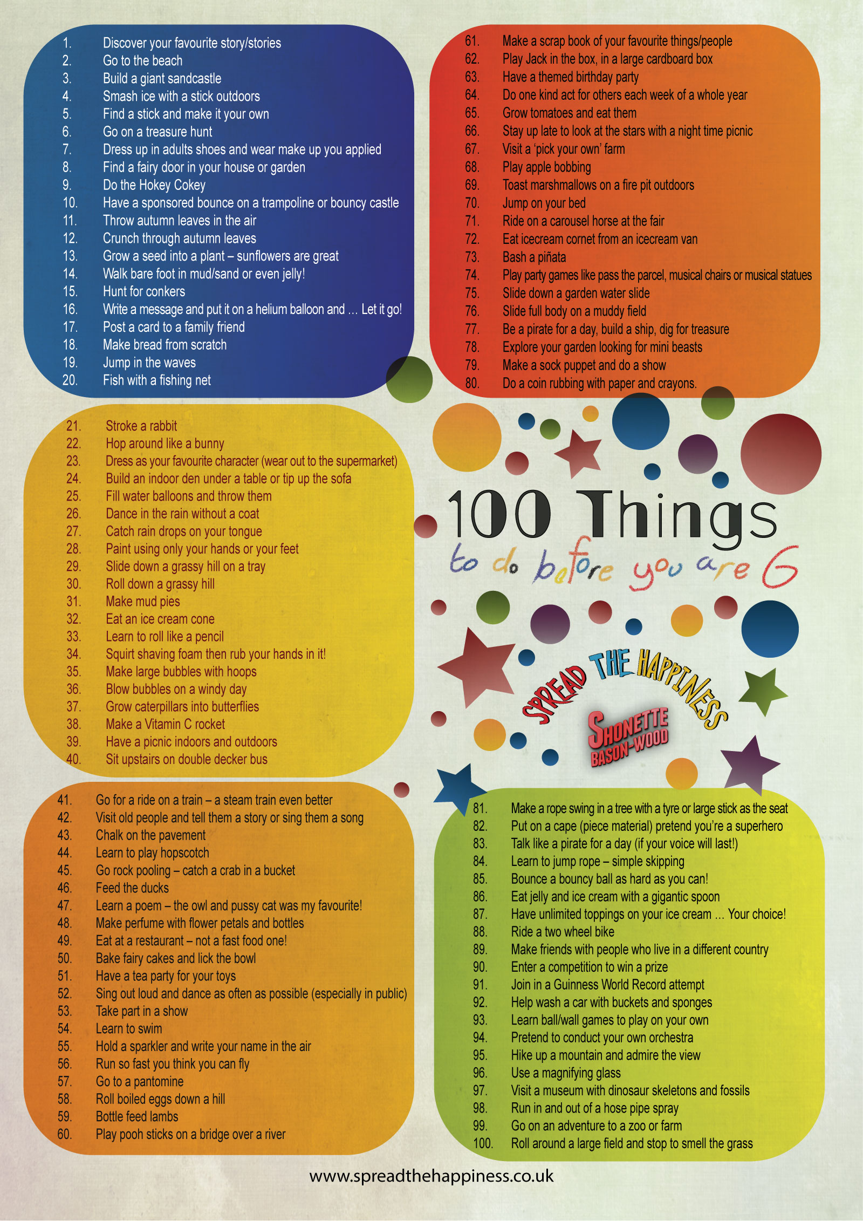
Classroom secrets - https://classroomsecrets.co.uk/free-home-learning-packs/
Twinkl – www.twinkl.co.uk/offer and enter the code – UKTWINKHELPS
Spread the Happiness - 100 things to do before you are 6 – https://www.fairmeadows.net/100-things-to-do-before-you-are-six/

