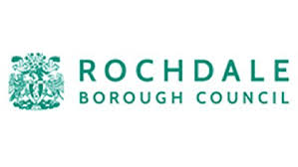

Revenues and Benefits

Free School Meal Eligibility Form

You can apply for free school meals if you and your child live in the borough. You must get one of the benefits listed overleaf and receive child benefit for the child you are responsible for.

If your child gets a free school meal the school will get additional funding known as a pupil premium. This money helps the school improve the education they provide.

You and your partner

Title | First Name | Last Name | National Insurance or NASS Number | Date of Birth | Date your qualifying benefit started | Relationship

Your dependent children list all your children

First Name | Last Name | Male/Female | Date of Birth | Date Started

Your Address ________________________________________ Postcode ____________________

Phone Number ________________________ Email Address ______________________________

I or we declare the information given on this form is correct and complete.

I or we understand that if the information given is incorrect or incomplete, you may take action against me or us. I or we understand that you may check the information given on this form.

I or we know that if my or our circumstances change after I or we make this claim then I or we must tell you.

Signature of parent or guardian ______________________________ Date ___________________

